**Ideation Phase**

**Define the Problem Statements**

|  |  |
| --- | --- |
| Date | 29 April 2023 |
| Team ID | NM2023TMID22230 |
| Project Name | Project - SQUID: Street Quality Identification |
| Maximum Marks | 2 Marks |

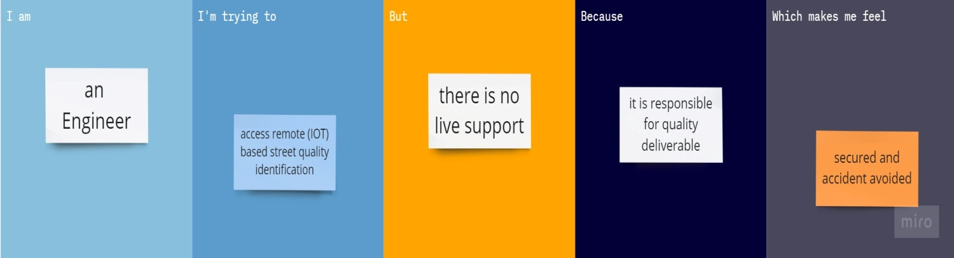

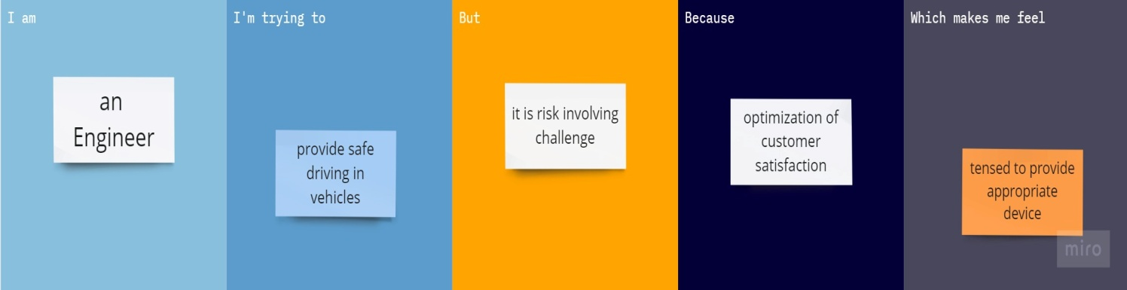

|  |  |  |  |  |  |
| --- | --- | --- | --- | --- | --- |
| **Problem Statement (PS)** | **I am (Customer)** | **I’m trying to** | **But** | **Because** | **Which makes me feel** |
| PS-1 | An Engineer | Access remote (IOT) based street quality identification | There is no live support | It is responsible for quality deliverable | Secured and accident avoided |
| PS-2 | An Engineer | Provide safe driving in vehicles | It is risk involving challenge | Optimization of customer satisfaction | Tensed to provide appropriate device |